Visual proteomics using whole-lamella 2D template matching

This manuscript was automatically generated on April 14, 2022.

## Authors

* **Johannes Elferich**  [0000-0002-9911-706X](https://orcid.org/0000-0002-9911-706X) ·  [jojoelfe](https://github.com/jojoelfe) RNA Therapeutic Institute, UMass Chan Medical School; HHMI
* **Nikolaus Grigorieff**  [0000-0002-1506-909X](https://orcid.org/0000-0002-1506-909X) ·  [nikogrigorieff](https://github.com/nikogrigorieff) RNA Therapeutic Institute, UMass Chan Medical School; HHMI

## Abstract

Localization of biomolecules inside a cell is an important goal of biological imaging. Fluorescence microscopy can localize biomolecules inside whole cells and tissues, but its ability to count biomolecules and accuracy of the spatial coordinates is limited by the wavelength of visible light. Cryo-electron microscopy (cryo-EM) provides highly accurate position and orientation information of biomolecules but is often confined to small fields of view inside a cell, limiting biological context. In this study we use a new data-acquisition scheme called “Defocus-Corrected Large-Area cryo-EM” (DeCo-LACE) to collect high-resolution cryo-EM data over entire sections (100 – 200 nm thick lamellae) of neutrophil-like mouse cells, representing 1% - 2% of the total cellular volume. We use 2D template matching (2DTM) to determine localization and orientation of the large ribosomal subunit in these sections, detect bound small ribosomal subunits and assign ribosomes to polysomes based on their relative orientations to each other. These data provide “maps” of translational activity across sections of mammalian cells. This new high-throughput cryo-EM data collection approach together with 2DTM will advance visual proteomics and complement other single-cell “omics” techniques, such as flow-cytometry and single-cell sequencing.

## Introduction

A major goal in understanding cellular processes is the knowledge of the amounts, location, interactions, and conformations of biomolecules inside the cell. This knowledge can be obtained by approaches broadly divided into label- and label-free techniques. In label-dependent techniques a probe is physically attached to a molecule of interest that is able to be detected by its strong signal, such as a fluorescent molecule. In label-free techniques, the physical properties of molecules themselves are used for detection. An example for this is proteomics using mass-spectrometry [1]. The advantage of label-free techniques is that they can provide information over thousands of molecules, while label-dependent techniques offer highly specific information for a few molecules. Especially spatial information can often only be achieved using label-dependent techniques, such as fluorescence microscopy [2].

Cryo-electron microscopy (cryo-EM) has the potential to directly visualize the arrangement of atoms that compose biomolecules inside of cells, thereby allowing label-free detection with high spatial accuracy. This has been called “visual proteomics” [3]. Since cryo-EM requires thin samples (<500nm), imaging of biomolecules inside cells is restricted to small organisms, thin regions of cells, or samples that have been suitably thinned. Thinning can be achieved either by mechanical sectioning [4] or by milling using a focused ion beam (FIB) [5]. This complex workflow leads to a low throughput of cryo-EM imaging of cells and is further limited by the fact that at the required magnifications, typical fields of view (FOV) are very small compared to mammalian cells, and the FOV achieved by label-dependent techniques such as fluorescence light microscopy. The predominant cryo-EM technique for the localization of biomolecules of defined size and shape inside cells is cryo-electron tomography [6]. However, the requirement of a tilt series at every imaged location and subsequent image alignment, severely limits the throughput for molecular localization.

An alternative approach is to identify molecules by their structural “fingerprint” in single projection using “2D template-matching” (2DTM) [7,8,9]. In this method a 3D model of a biomolecule is used as a template to find 2D projections that match the molecules visible in the electron micrographs. This method requires a projection search on a fine angular grid, and the projections are used to find local cross-correlation peaks with the micrograph. Since the location of a biomolecule in the z-direction causes predictable aberrations to the projection image, this method can be used to calculate complete 3D coordinates and orientations of a biomolecule in a cellular sample [8]

Hematopoiesis is the process of generating the various cell types of the blood in the bone marrow. Dysregulation of the process results in diseases like leukemia. Understanding how hematopoietic stem and progenitor cells are programmed to differentiate to the appropriate cell type would be provide new insight how hematopoiesis can be misregulated. Of special interest is the regulation of translation during hematopoiesis. This is exemplified by the observation that genetic defects in the ribosome machinery often leads to hematopoietic disease[10]. As such direct quantification of ribosome location, number and conformational states could lead to new insight into hematopoietic disease [11].

Here we apply 2DTM of ribosomes to cryo-FIB milled neutrophil-like murine cells [12]. To increase the amount of collected data and to provide unbiased sampling of the whole lamella, we devised a new data-acquisition scheme, Defocus-corrected large area cryo-electron microscopy (DeCo-LACE). We characterize aberration cause by the large image shifts and highly focused beams used to scan the sample and find that they can be adequately corrected to enable ribosome detection by 2DTM. The resulting data provide a description of ribosome distribution in an entire lamellae, which represent roughly 2% of the cellular volume. We find highly heterogeneous density of ribosome within the cell and can identify discrete clusters of presumably translationally active ribosomes, by testing for the presence of the small ribosomal subunit. The high accuracy of location and orientation of each detected ribosome also allows us to cluster ribosome molecules into potential polysomes. Analysis of the throughput in this method suggests that for the foreseeable future computation will be the bottleneck for visual proteomics.

## Materials and Methods

### Grid preparation

ER-HoxA9 cells were maintained in RPMI medium supplemented with 10% FBS, penicillin/streptomycin, SCF, and estrogen [12] at 37C and 5% CO2. 120 h prior to grid preparation, cells were washed twice in PBS and cultured in the same medium except without estrogen. Differentiation was verified by staining with Hoechst-dye and inspection of nuclear morphology. Cells were then counted and diluted to $1⋅{10}^{6}$ cells/ml. Grids (either 200 mesh copper grids, with a sillicone-oxide and 2 µm holes with a 2 µm spacing or 200 mesh gold grids with a thin gold film and 2 µm holes in 2 µm spacing) were glow-discharged from both sides using a 15 mA for 45 s. 3.5 µl of cell suspension was added to grids on the thin-film side and grids were blotted from the back side using a GP2 cryoplunger (Leica) for 8 s and rapidly plunged into liquid ethane at -185 °C.

### FIB-milling

Grids were loaded into an Acquilos 2 FIB/SEM (Thermo Fisher) microscope with a stage cooled to -190 °C. Grids were sputter-coated with platinum for 15 s at 45 mA and then coated with a layer of platinum-precursor by opening the GIS-valve for 45 s. An overview of the grid was created by montaging SEM images and isolated cells at the center of gridsquares were selected for FIB-milling. Lamellae were generated automatically using the AutoTEM software (Thermo Fisher), with the following parameters:

* Milling angle: 20°
* Rough milling: 3.2 µm thickness, 0.5nA current
* Medium milling: 1.8 µm thickness, 0.3nA current, 1.0° overtilt
* Fine milling: 1.0 µm tchickness, 0.1nA current, 0.5° overtilt
* Finer milling: 700 nm thickness, 0.1nA curent, 0.2° overtilt
* Polish 1: 450nm thickness, 50 pA current
* Polish 2: 200nm thickness, 30 pA current

This resulted in 6-8 μm wide lamellae with 150-250 nm thickness as determined by FIB-imaging of the lamellae edges.

### Data collection

Grids were loaded into a Titan Krios TEM (Thermo Fisher) operated at 300 keV, and equipped with a BioQuantum energy filter (Gatan) and K3 camera (Gatan). The microscope was aligned using a cross-grating grid on the stage. Prior to each session we carefully performed the Image/Beam calibration in nanoprobe. Then we set the magnification to a pixel size of 1.76Å and condensed the beam to ~ 900nm diameter, resulting in the beam being completely visible on the camera. To establish fringe-free conditions, the “Fine eucentric” procedure of SerialEM was used to move a square of the cross-grating grid to the eucentric position of the microscope. The effective defocus was then set to 2 μm, using the “autofocus” routine of SerialEM. The objective focus of the microscope was changed until no fringes were visible. The stage was then moved in Z until images had an apparent defocus of 2 μm. The difference in stage Z-position between the eucentric and fringe-free conditions was used to move other areas into fringe-free condition.

Low magnification montages were used to find lamellae, and lamellae that were sufficiently thin and free of contamination were selected for automated data collection. Overview images of each lamella were taken at 2250x magnification (39 Å pixel-size). The corners of the lamella in the overview image were manually annotated in SerialEM and translated into beam image shift values using SerialEM calibration. A hexagonal pattern of image shift positions was calculated that covered the area between the four corners in a serpentine way, with a sqrt(3) * 400 nm horizontal spacing and 800 nm vertical spacing. Exposures were taken at each position with a 30 e-/Å ${}^{2}$ total dose. After each exposure the defocus was estimated using the ctffind function of SerialEM and the focus for the next exposure was corrected by the difference between the estimated focus and the desired defocus of 800 nm. Furthermore, after each exposure the deviation of the beam from the center of the camera was measured and corrected using the “CenterBeamFromImage” command of SerialEM.

After data collection, a 20s exposure at 2250x magnification of the lamella at 200 μm defocus was taken for visualization purposes. A python script implementing this procedure is available at [Link to repo].

### Data pre-processing

To avoid influence of the beam edge on motion-correction, only a quarter of the movie in the center of the camera was considered for calculation of the estimated motion. After movie frames were aligned and summed a mask for the illuminated area was calculated by lowpass filtering the image with a 100-Å cutoff, thresholding the image at 10% of the maximal value and then lowpass filtering the mask with a 100-Å cutoff to smooth the mask edges. This mask was then used to select un-illuminated areas in the image and fill the pixels with Gaussian noise, with the same mean and standard deviation as the illuminated area. A custom version of the unblur program [cite] implementing this procedure is available at [link to decolace branch]. The contrast-transfer function (CTF) was estimated using ctffind, searching between 0.02 and 2 μm defocus.

### 2DTM

The search template was generated from the cryo-EM structure of the mouse large ribosomal subunit (PDB 6SWA) using the cryo-EM simulator implemented in *cis*TEM [cite]. The atomic coordinates corresponding to subunit Epb1 were deleted from the model and the simulator was used to calculate a density map from the atomic coordinates. The match_template program [cite] was used to search for this template in the movie-aligned, exposure-filtered and masked images, using a 1.5° angular step in out-of-plane angles and 1.0° in-plane. 11 defocus planes in 20 nm steps centered around the ctffind defocus estimates were searched. Targets were defined as detected when their matches with a template produced peaks with a signal-to-noise ratio (SNR) above a threshold of 7.75, which was chosen based on the one-false-positive-per-tile criterion [cite].

### DeCo-LACE data processing

An overview of the data analysis pipeline is shown in Fig. 6. Initial coordinates of each tile $i$, ${\text{c}}_{init,i}$ were derived from the beam image shift of the tile, $BIS_{i}$, and the ISToCamera matrix $IC$:

${\text{c}}_{init,i}=IC⋅BIS_{i}$

To refine the montage, a list of overlapping tile pairs $\left|{\text{c}}_{i}−{\text{c}}_{j}\right|<900\text{nm}$ were compiled and the offsets ${\text{o}}_{i,j}={\text{c}}_{i}−{\text{c}}_{j}$ were refined by using a masked cross-correlation of the overlap region as implemented in the scikit-image package [cite]. Refined coordinates were then derived by least-squares minimization of the new offsets and tile positions:

$min\sum_{pairs}{{\left({\text{o}}_{refined,i,j}−\left({\text{c}}_{i}−{\text{c}}_{j}\right)\right)}^{2}}$

using the scipy package [cite]. This refinement was repeated once more to arrive at the final tile alignment.

The x,y coordinates of target $n$ detected by 2DTM in the tile $i$, ${\text{m}}_{n,i}^{\text{T}}$, was transformed into the montage frame by adding the coordinate of the tile.

${\text{m}}_{n}^{\text{M}}={\text{m}}_{n,i}^{\text{T}}+{\text{c}}_{i}$

The z coordinate of each target was calculated as the sum of the defocus offset for the target, the estimated defocus of the tile, and the nominal defocus of the microscope when the tile was acquired. The python scripts used for data processing are available under [repolink].

## Results

### 2DTM detects large ribosomal subunits in cryo-FIB lamellae of mammalian cells

To test whether we could detect individual ribosomes in mammalian cells we prepared cryo-lamellae of mouse neutrophil-like cells. Low-magnification images of these lamellae clearly shows cellular features consistent with a neutrophil-like phenotype, mainly a segmented nucleus and a plethora of membrane-organelles, corresponding to the granules and secretory vesicles of neutrophils (Fig. 1A). We then proceeded to acquire micrographs on these lamellae with a defocus of 0.5-1.0 μm, 30 e-/Å2/s exposure and 1.5 Å pixel size. We manually selected multiple locations in the lamellae and acquired micrographs using standard low-dose techniques where focusing is performed on a sacrificial area. The resulting micrographs showed smooth bilayered membranes and no signs of crystalline ice (Fig. 1C,D), indicating successful vitrification.

We used an atomic model of the 60S mouse ribosomal subunit (6SWA) for 2DTM. In a subset of images the distribution of cross-correlation scores significantly exceeded the distribution expected images devoid of detectable targets. In the resulting scaled maximum-intensity projections (MIPs), clear peaks with SNR values up to 10 were apparent (Fig. S1A). Using a threshold criterion to select significant targets (see Methods) we found that in images of cytosolic compartments there were 10-500 ribosomes in the imaged areas (Fig. 1B-E). Notably, we found no targets in areas corresponding to the nucleus (Fig. 1B) or mitochondria (Fig. 1D). In the cytoplasm we found a highly variable number of targets, only ~ 50 in some areas (Fig. 1E) and up to 500 in others (Fig. 1C). This is a ten-fold difference in local ribosome concentration, highlighting the importance of imaging larger areas of a lamella to gain a complete picture of target distributions. We therefore set out to collect cryo-EM data for 2DTM from mammalian cell lamellae in a high-throughput unbiased fashion.

### DECO-LACE for 2D imaging of whole lamellae

In order to obtain high-resolution data from complete lamellae, we used a new approach for data collection. This approach uses three key strategies: (1) every electron that exposes a fresh area of the sample is collected on the camera (2) image shift is used to precisely and quickly raster the surface of a lamella and (3) focusing without using a sacrificial area (Fig. 2A).

To ensure that every electron exposing a fresh area of the sample is captured by the detector, we adjusted the electron beam size to be entirely contained by the detector area. During canonical low-dose imaging the microscope is configured so that the focal plane is identical to the eucentric plane of the specimen stage. This leaves the C2 aperture out of focus, resulting in ripples at the edge of the beam (Fig. 2D). While these ripples are low-resolution features that likely do not interfere with 2DTM [cite], we also tested data collection under conditions where the C2 aperture is in focus (“fringe-free”, Fig. 2E).

We then centered a lamella on the optical axis of the microscope and used the image shift controls of the microscope to systematically scan the whole surface of the lamella in a hexagonal pattern (Fig. 2A,C). Instead of focusing on a sacrificial area, we determined the defocus from every exposure after it was taken. The defocus was then adjusted based on the difference between desired and measured defocus (Fig. 2B). Since we used a serpentine pattern for data collection, every exposure was close to the previous exposure, making large changes in the defocus unlikely. Furthermore, we started our acquisition pattern on the platinum deposition edge to make sure that the initial exposure where the defocus was not yet adjusted did not contain any biologically relevant information.

We used this strategy to collect data on eight lamellae, four using the eucentric focus condition, hereafter referred to as LamellaEUC, and four using the fringe-free condition, hereafter referred to as LamellaFFF(Fig. S2). We were able to collect data with a highly consistent defocus of 800nm (Fig. 2F), both in the eucentric focus and fringe-free focus condition. To ensure that data were collected consistently, we mapped defocus values as a function of the applied image shift (Fig. S3A). This demonstrated that the defocus was consistent across a lamella, with rare outliers and in images containing contamination. We also plotted the measured objective astigmatism of each lamella and found that it varies with the applied image shift, becoming more astigmatic mostly due to image shift in the X direction (Fig. S3B). While approaches exist to correct for this during the data collection [cite], we opted to not use these approaches in our initial experiments. We reasoned that because 2DTM depends on high-resolution information, this would be an excellent test of how much these aberration affect imaging.

We assembled the tile micrographs into a montage using the image-shift values and the SerialEM calibration followed by cross-correlation based refinement (see Methods). In the resulting montages the same cellular features visible in the overview images are apparent (Fig. S3G-J), however due to the high magnification and low defocus many more details, such as the membrane bilayer seperation can be observed. For montages collected using the eucentric condition, there are clearly visible fringes at the edges between the tiles, which are absent in the fringe-free focus montages. In our analysis below, we show that these fringes do not impede target detection by 2DTM, making them primarily an aesthetic issue. We also note that the serpentine tiling pattern is visible in the montages, which we believe is due to the non-linear behaviour of the K3 camera (see Dicussion).

The montages show membrane vesicles and granules with highly variable sizes and density. We found furthermore that a substantial number of granules with a high density seemed to contain a membrane-enclosed inclusion with density similar to the surrounding cytosol (Fig. [TODO]). [Describe measurements]

### 2DTM of DeCo-LACE data reveals ribosome distribution in cellular cross-sections

In our initial attempts of using 2DTM on micrographs acquired with the DeCo-LACE protocol, we did not observe any SNR peaks above threshold using the large subunit of the mouse ribosome (Fig. S4A). We reasoned that the edges of the beam might interfere with motion-correction of the movies as they represent strong low-resolution features that do not move with the sample. When we cropped the movie frames to exclude the beam edges the estimated amount of motion increased (Fig. S4B), consistent with successful tracking of sample motion. Furthermore, in the motion-corrected average we could identify significant SNR peaks (Fig. S4B), confirming to high sensitivity of 2DTM to the presents of high-resolution signal preserved in the images by the motion correction. To streamline data processing, we implemented a function in unblur to consider only defined central area of a movie for estimation of sample motion, while still averaging the complete movie frames (Fig. S4B). Using this approach, we motion-corrected all tiles in the eight lamellae and found consistently total motion below 1 Å per frame (Fig. S5 A). In some lamellae we found increased motion in the lamella center, which indicates areas of variable mechanical stability within FIB-milled lamellae. In some micrographs we also observed that the beam edges gave rise to artifacts in the MIP and numerous false-positive detections at the edge of the illuminated area (Fig. TODO). A similar phenomenon was observed on isolated “hot” pixels in unilluminated areas. To overcome this issue we implemented a function in unblur to replace unillluminated areas in the micrograph with Gaussian noise (see Methods), with mean and standard deviation matching the illuminated portion of the micrograph (Fig. TODO). Together, these pre-processing steps enabled us to perform 2DTM on all tiles of the eight lamellae.

We used the refined tile positions to calculate the positions of the detected LSUs in the lamellae (Fig. 4 A, Fig. 5 A). Overlaying these positions of the lamellae montages reveal ribosome distribution throughout the FIB-milled slices of individual cells. Organelles like the nucleus and mitochondria only showed sporadic targets detected with low SNRs, consistent with the estimated false-positive rate on one per tile. For each detected target we also calculated the Z positions from the individual estimated defocus and defocus offset for each tile. When viewed from the side the ribosome positions therefore show the slight tilts of the lamellae relative to the microscope frame of reference (Fig. 4 B, Fig. 5 B). Furthermore, the side views indicated that lamellae were thinner at the leading edge. Indeed, when we plotted the transmitted beam intensities in individual tiles as a function of image shift we observed substantially higher intensities at the leading edge, which in energy-filtered TEM indicates a thinner sample [cite]. Even though we prepared the lamellae with the “overtilt” approach [cite], this means that ribosome densities across the lamellae can be skewed by a change in thickness, and better sample preparation methods are needed to generate more even samples.

Close inspection of the ribosome positions in the lamellae revealed several interesting features. Ribosomes could be seen associating with membranes, in patterns reminiscent of the rough endoplasmic reticulum (Fig. 4 C, Fig. 5 C) or the outer nuclear membrane (Fig. 4 D). We also observed ribosomes forming ring-like structures (Fig. 4 E), potentially indicating circularized mRNAs [cite]. While ribosomes were for the most part excluded from the numerous granules observed in the cytoplasm, in some cases we observed clusters of ribosomes in low density inclusions in double-membraned granules described earlier (Fig. 4 F, Fig. 5 D,E). It is, in principle, possible that these targets are situated above or below the imaged granules, since the granule positions in Z cannot be determined using 2D projections. However, in the case of Fig. 5 E, the detected ribosomes span the whole lamella in the Z direction, while positions above or below a granule would result in ribosomes situated exlusively at the top or bottom of the lamella. This conclusive evidence of ribosomes in inclusions is consistent with the earlier hypothesis that the inclusions are of cytoplasmic origin.

Between the eight lamellae we found different number of detected targets (Fig. 3 A). LamellaEUC 1 has in the most targets, but also has the largest surface area and contained cytoplasm from two cells. LamellaFFF 4 had the fewest detected targets, but this particular lamella was dominated by a circular section of the nucleus, with only small pockets of cytoplasm (Fig. S2). In an attempt to normalize for these differences in lamella surface area, we compared the number of detected targets per tile in tiles that contained more than one target, which should exclude tiles with non-cytosolic content (Fig. 3 B). While this measure had less variablity, there were still differences. LamellaEUC 4 had not only the fewest targets, but also the lowest density, which could be due to lamella being thinnest, or due to a section of the cells with a lower concentration of ribosomes. LamellaFFF 3 had a substantially higher number of ribosomes per tile. Since all of these lamellae were made from identical cells under identical conditions, this underscores the necessity to collect data from large numbers of lamellae to capture the inherent variability. When comparing the distribution of scores between lamellae, we found them to be fairly comparable with a median of [todo get values, test]. LamellaEUC 1 had slightly lower scores compared to the rest, potentially due to its large size and connected mechanical instability during imaging. Overall, we did not observe differences in the number or SNR of detected targets between eucentric or fringe-free illumination conditions that were bigger than the observed inter-lamella variability.

Since the SNR values of 2DTM are highly sensitive to image quality, we reasoned we could use them to verify that DeCo-LACE does not introduce a systematic loss of image quality. We considered non-parallel illumination introduced by the unusually condensed beam and uncharacterized aberrations near the beam periphery. When plotting the SNR values of detected targets in all eight lamellae as a function of their location in the tiles, we found uniformly high SNR values throughout the illuminated areas for both eucentric and fringe-free focus illumination, demonstrating that both illumination schemed are suitable for DeCo-LACE.

We also wondered whether large image shifts would lead aberration due to the astigmatism or beam tilt [cite]. [TODO plot scores vs BIS, euc vs fff]

### Computation is the bottleneck of visual proteomics

As described above, the variability of lamellae, both in terms of experimental parameters including area, thickness and mechanical stability, and in terms of biology, such as selection of cell type and location of the section within the cell, requires the collection orders of magnitude more data to draw quantitative and statistically relevant conclusions about the number and location of molecules under different experimental conditions. The samples used were prepared in two 24 h sessions on a FIB/SEM instrument, and imaging was performed during another two 24h session on the TEM microscope. Inspections of the timestamps of the raw data files revealed that the milling time per lamella was ~30 minutes and TEM imaging was accomplished in ~10 seconds per tile or 90 minutes for a ~ 6x6 μm lamella. Processing of the data, however, took substantially longer. Specifically, 2DTM of all tiles took approximately one week per lamella on 32 A100 GPUs. Computation is therefore a bottleneck in our current workflow, and further optimizations of the algorithm may be necessary increase throughput. Alternatively, this bottleneck could be reduced by increasing the number of processing units.

## Discussion

* Elizabeth Wright and Grant Jensen Montage tomography papers
* Waffle method for higher throughput, automation of fib-milling
* Throughput and bottlenecks
* lamella mechanical properties, radiation damage, other ways to to thin?
* eucentric vs fringe free illumination
* Visual proteomics
* Granules containing ribosomes?
* Threshold implications (no detected targets in most images)
* K3 not linear

## Figures

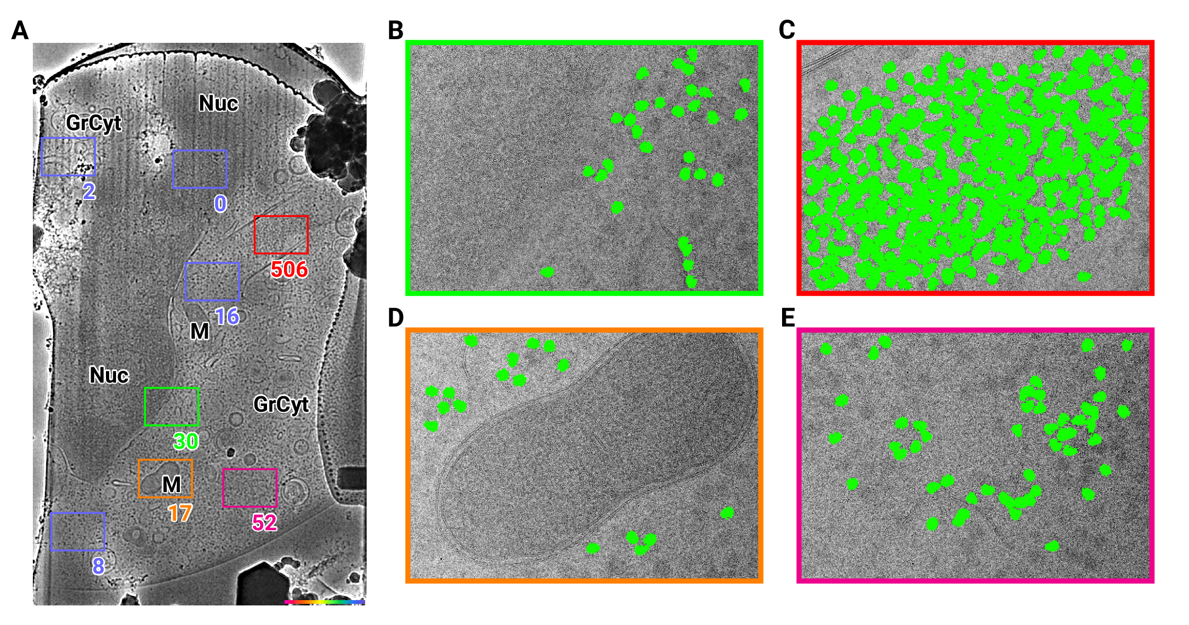

Figure 1: 2D template matching of the large subunit of the ribosome in fib-milled neutrophil-like cells. (A) Overview image of the lamella. Major cellular regions are labeled, as Nucleus (Nuc), Mitochondria (M), and granular cytoplasm (GrCyt). FOVs where high-magnification images for template matching where acquired are indicated as boxes with the number of detected targets indicated on the bottom right. FOVs displayed in Panels B-E are color-coded. (B-E) FOVs with projection of detected ribosome LSUs shown in green. (B) Perinuclear region, the only detected targets are in the cytoplasmic half. (C) Cytoplasmic region with high density of ribosomes. (D) Mitochondrium, as expected there are only targets in the cytoplasmic region. (E) Cytoplasm, with low density of ribosomes.

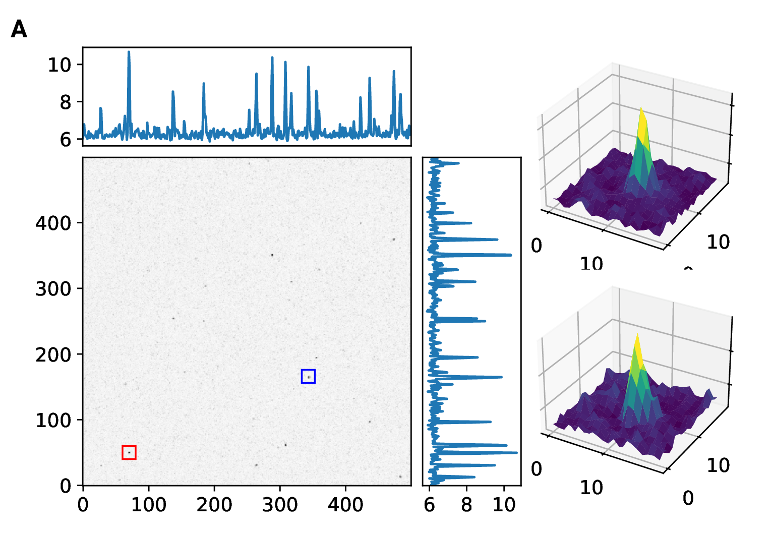

Figure S1: 2D template matching of the large subunit of the ribosome in fib-milled neutrophil-like cells. (A) Maximum intensity projection (MIP) of micrograph shown in Figure 1. (B+C) 3D plot of MIP regions indicated by color boxes in Panel A

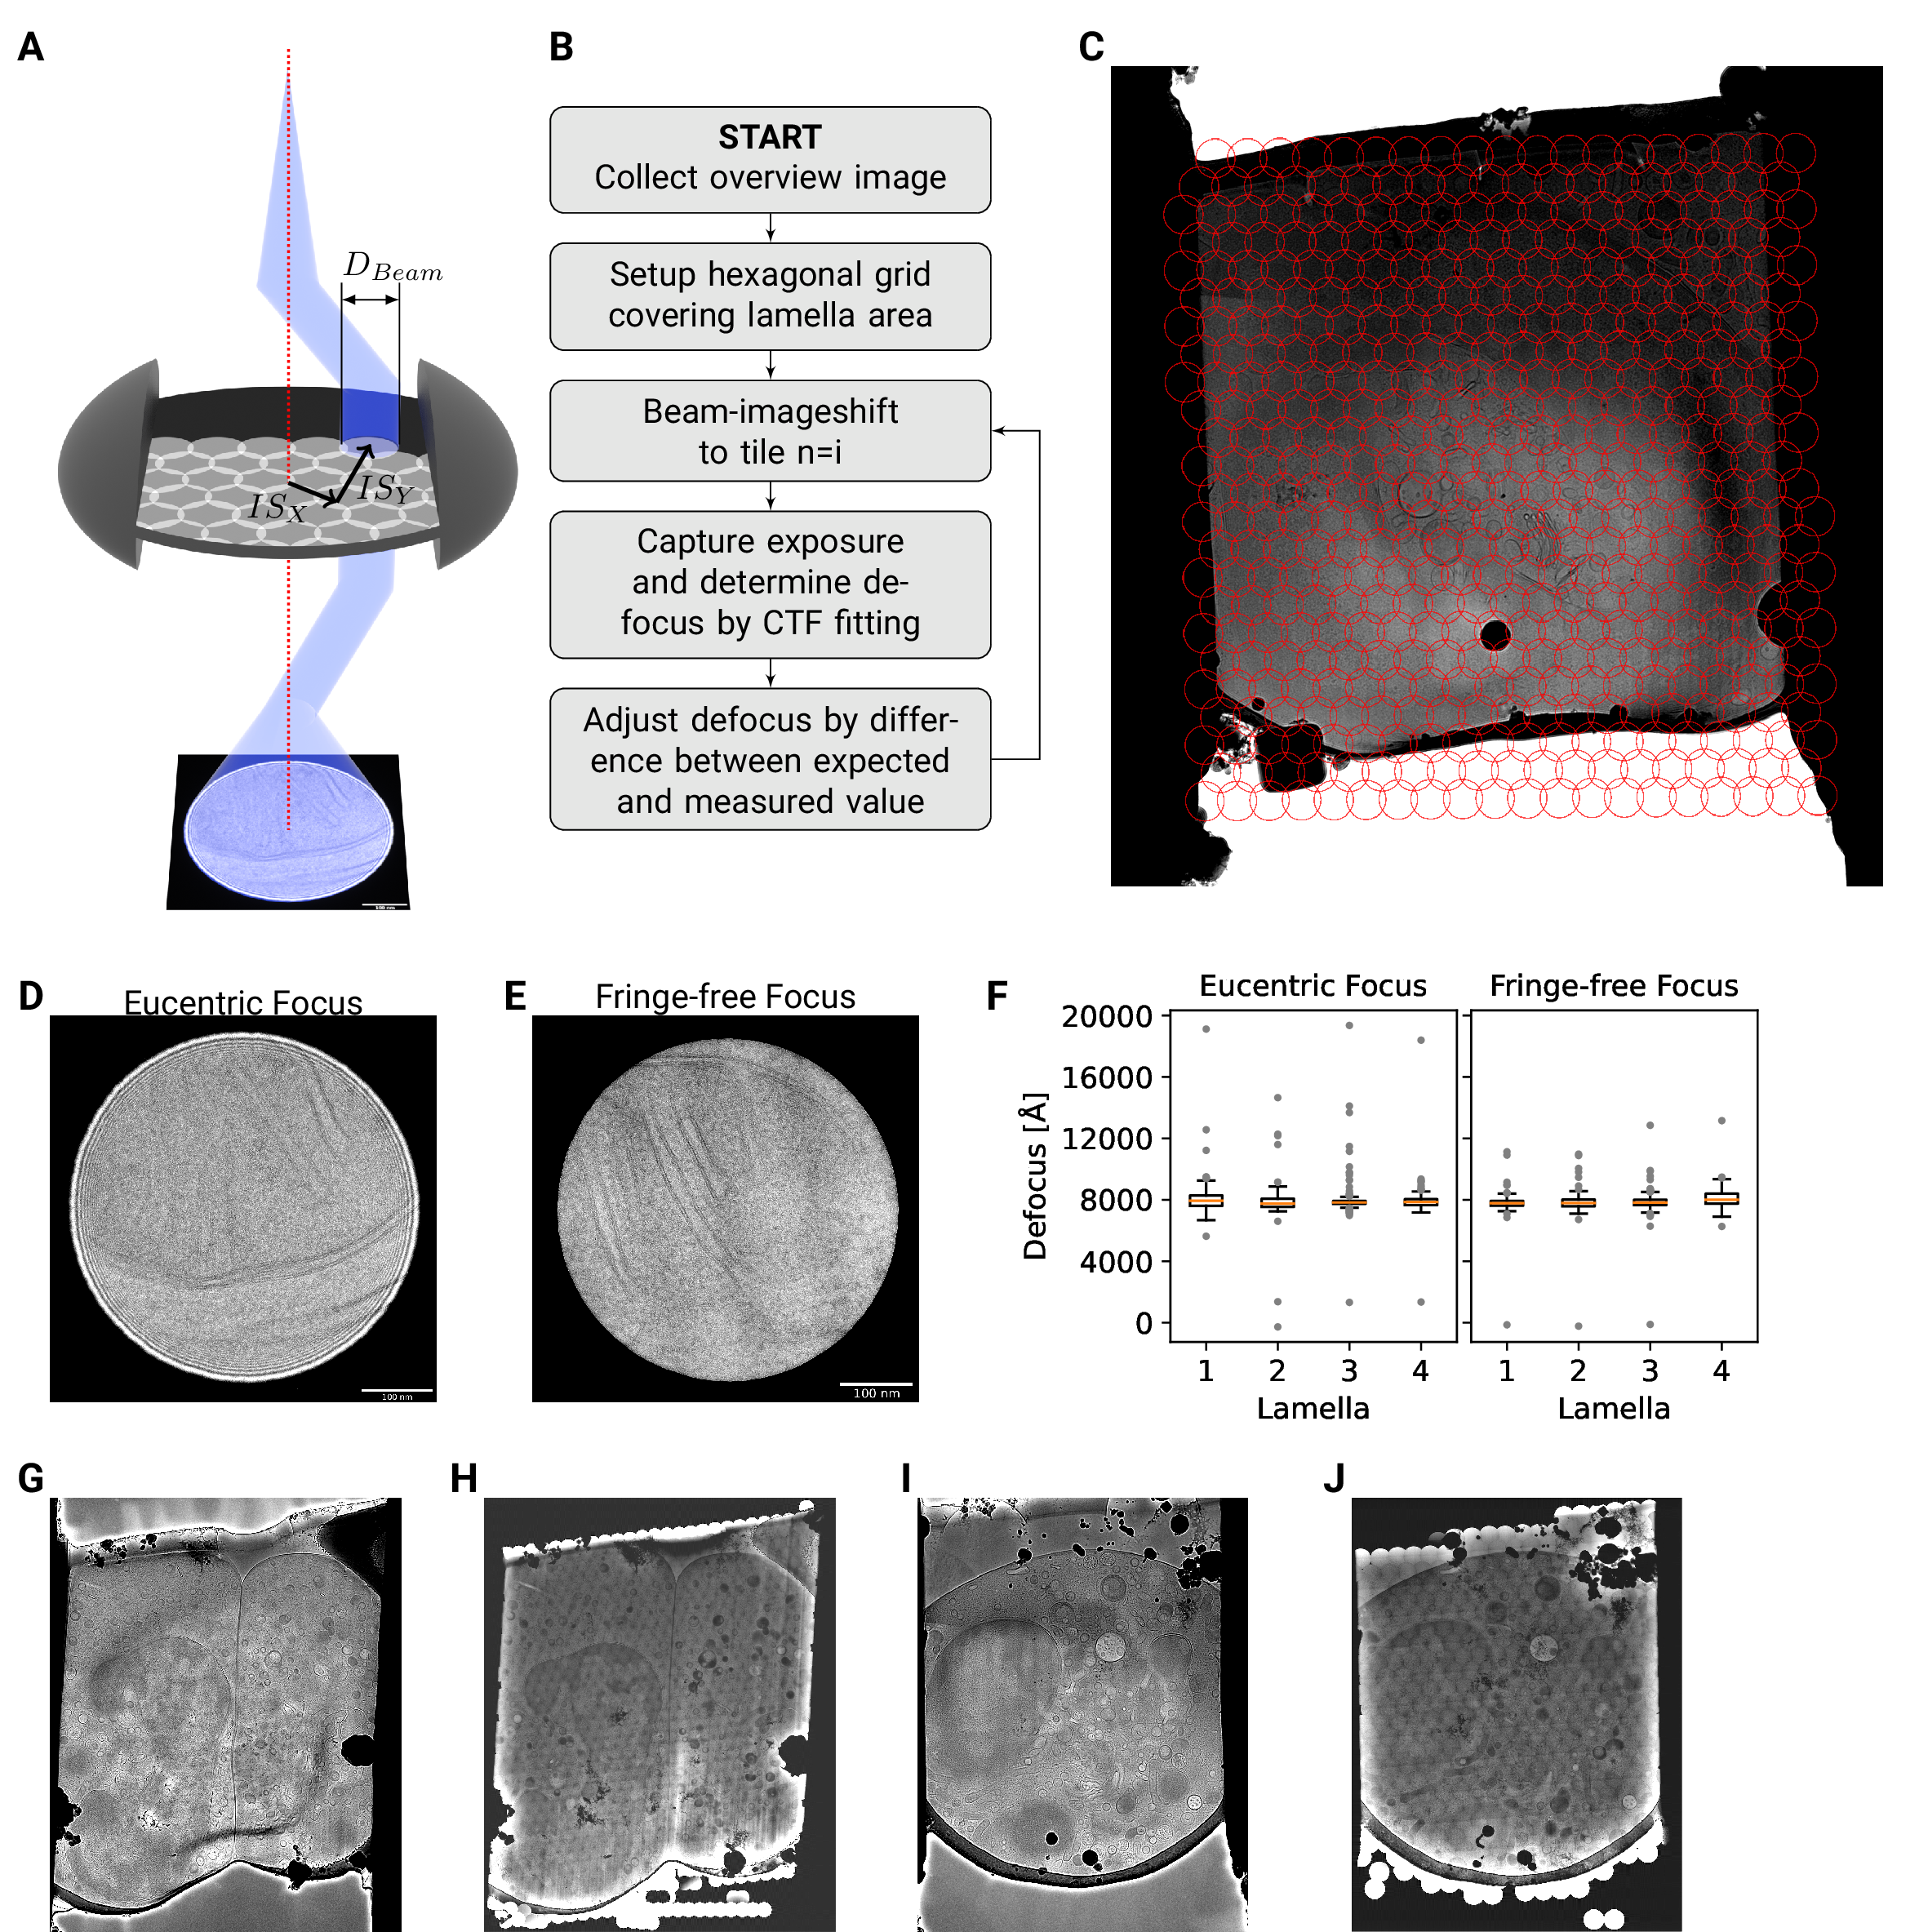

Figure 2: DeCo-LACE approach. (A) Graphic demonstrating the data-collection strategy for DeCo-LACE. The electron beam is condensed to a diameter $D_{Beam}$ that allows captured of the whole illuminated area on the camera. Beam image shift along X and Y ($BIS_{X}$,$ $BIS_{Y}$) is used to scan the whole lamella. (B) Diagram of the collection algorithm. (C) Example overview image of a lamella with the designated acquisition positions and the used beam diameter indicated with red circles. (D+E) Representative micrographs takne with a condensed beam at eucentric focus (D) or fringe-free focus (E). (F) Boxplot of defocus measured by ctffind of micrographs taken by the DeCo-Lace approach on four lamella images at eucentric focus and four lamella imaged with fringe-free focus. (F+G) Lamella overview images of lamella imaged at eucentric focus. (F) Overview image taken at low magnification (40Å pixel size). (G) Overview created by montaging high magnification images taken with the DeCo-Lace approach (1.5Å pixelsize). (H+I) Lamella overview images of lamella imaged at fringe-free focus. (H) Overview image taken at low magnification (40Å pixel size). (I) Overview created by montaging high magnification images taken with the DeCo-Lace approach (1.5Å pixelsize)

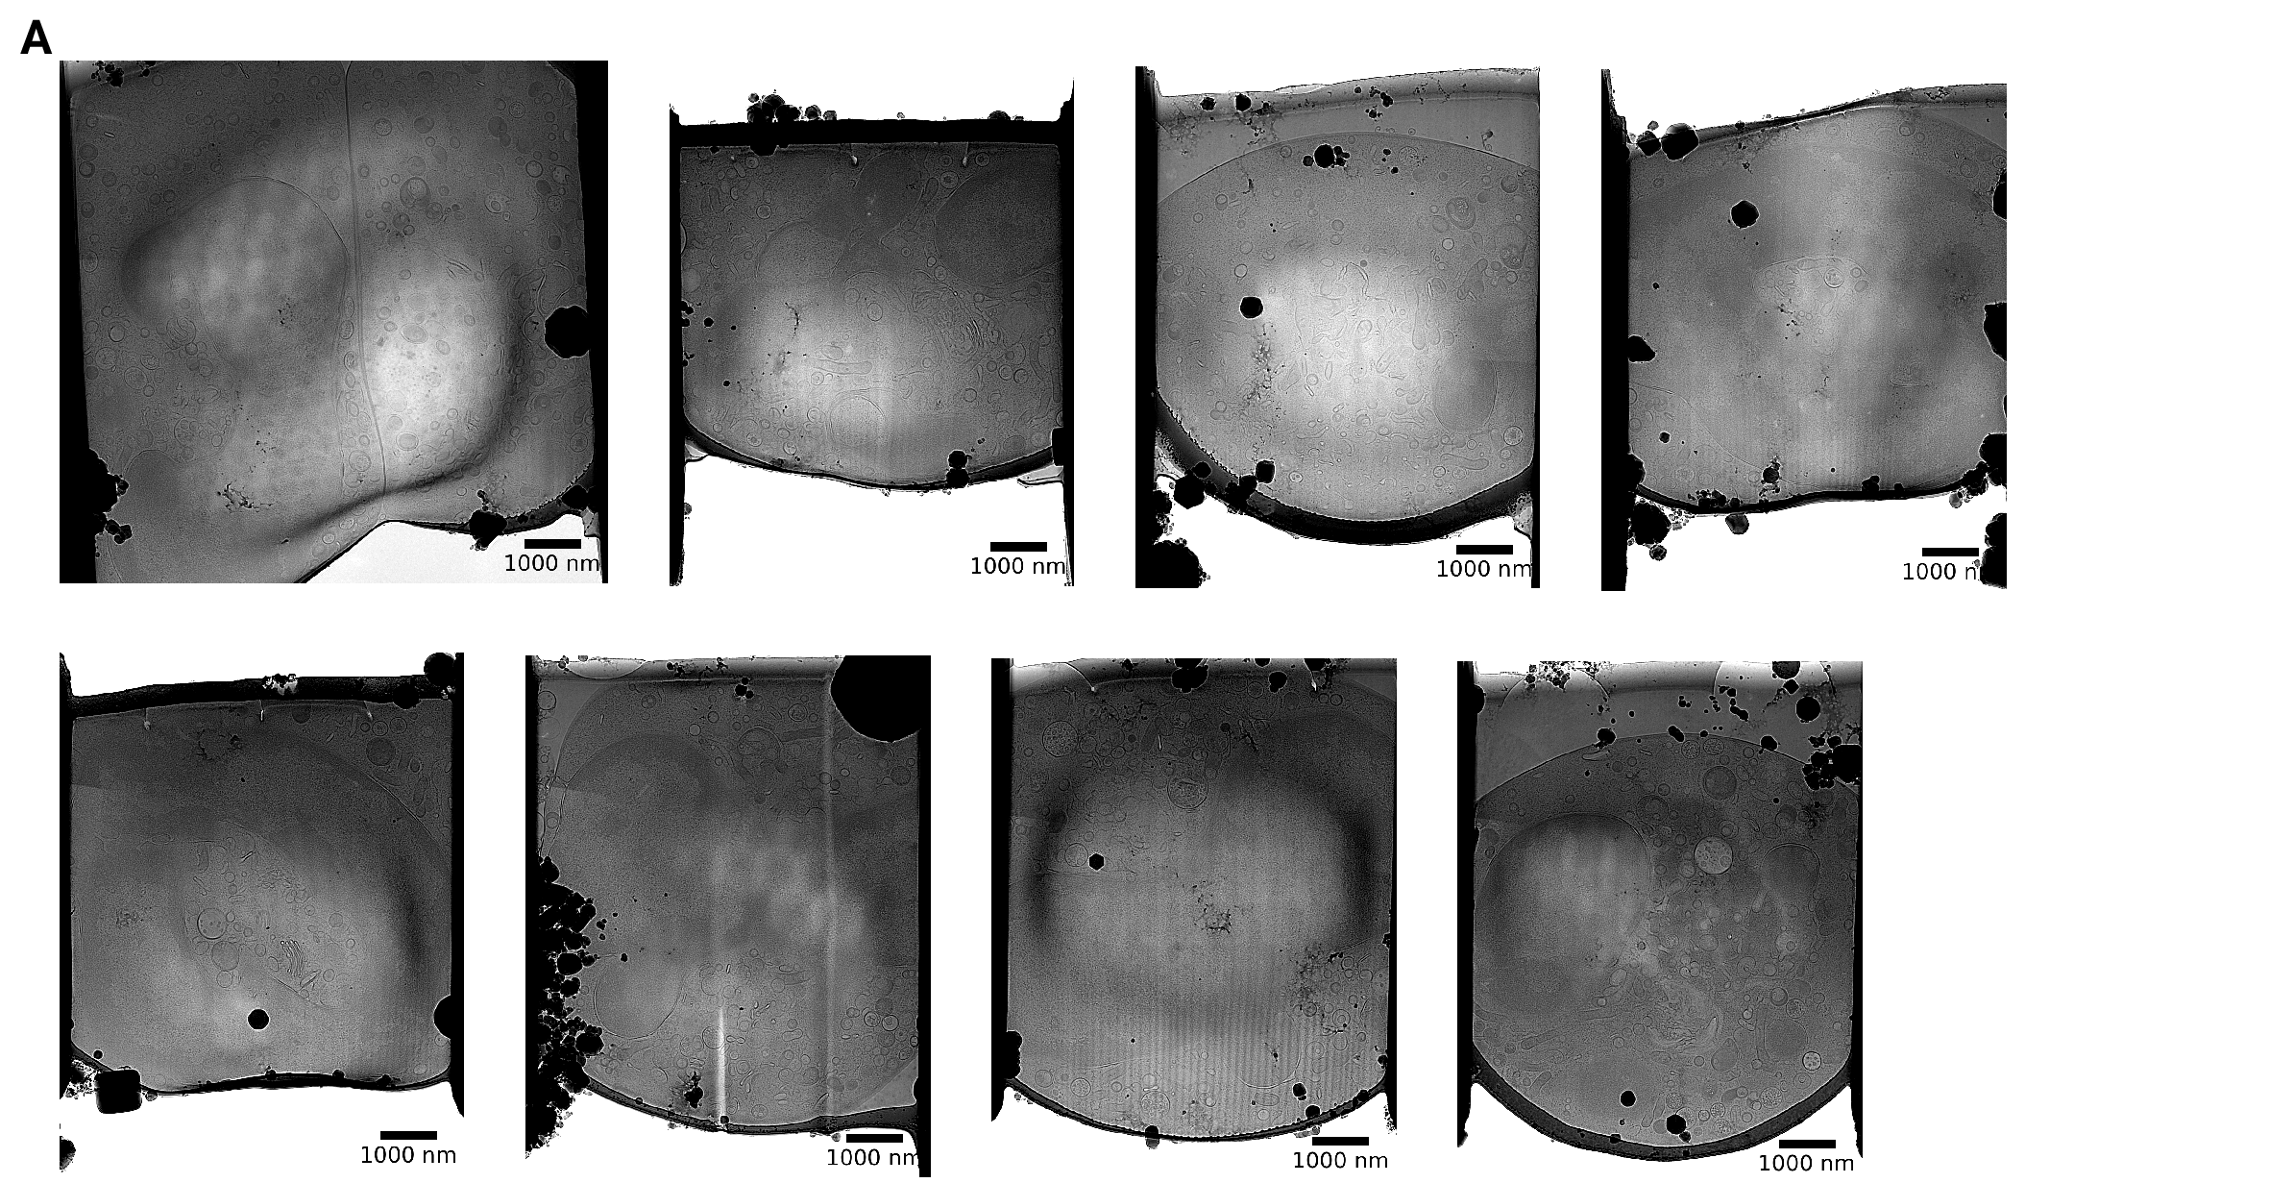

Figure S2: Overview images of lamellae imaged using the DeCo-LACE approach taken at low-magnification

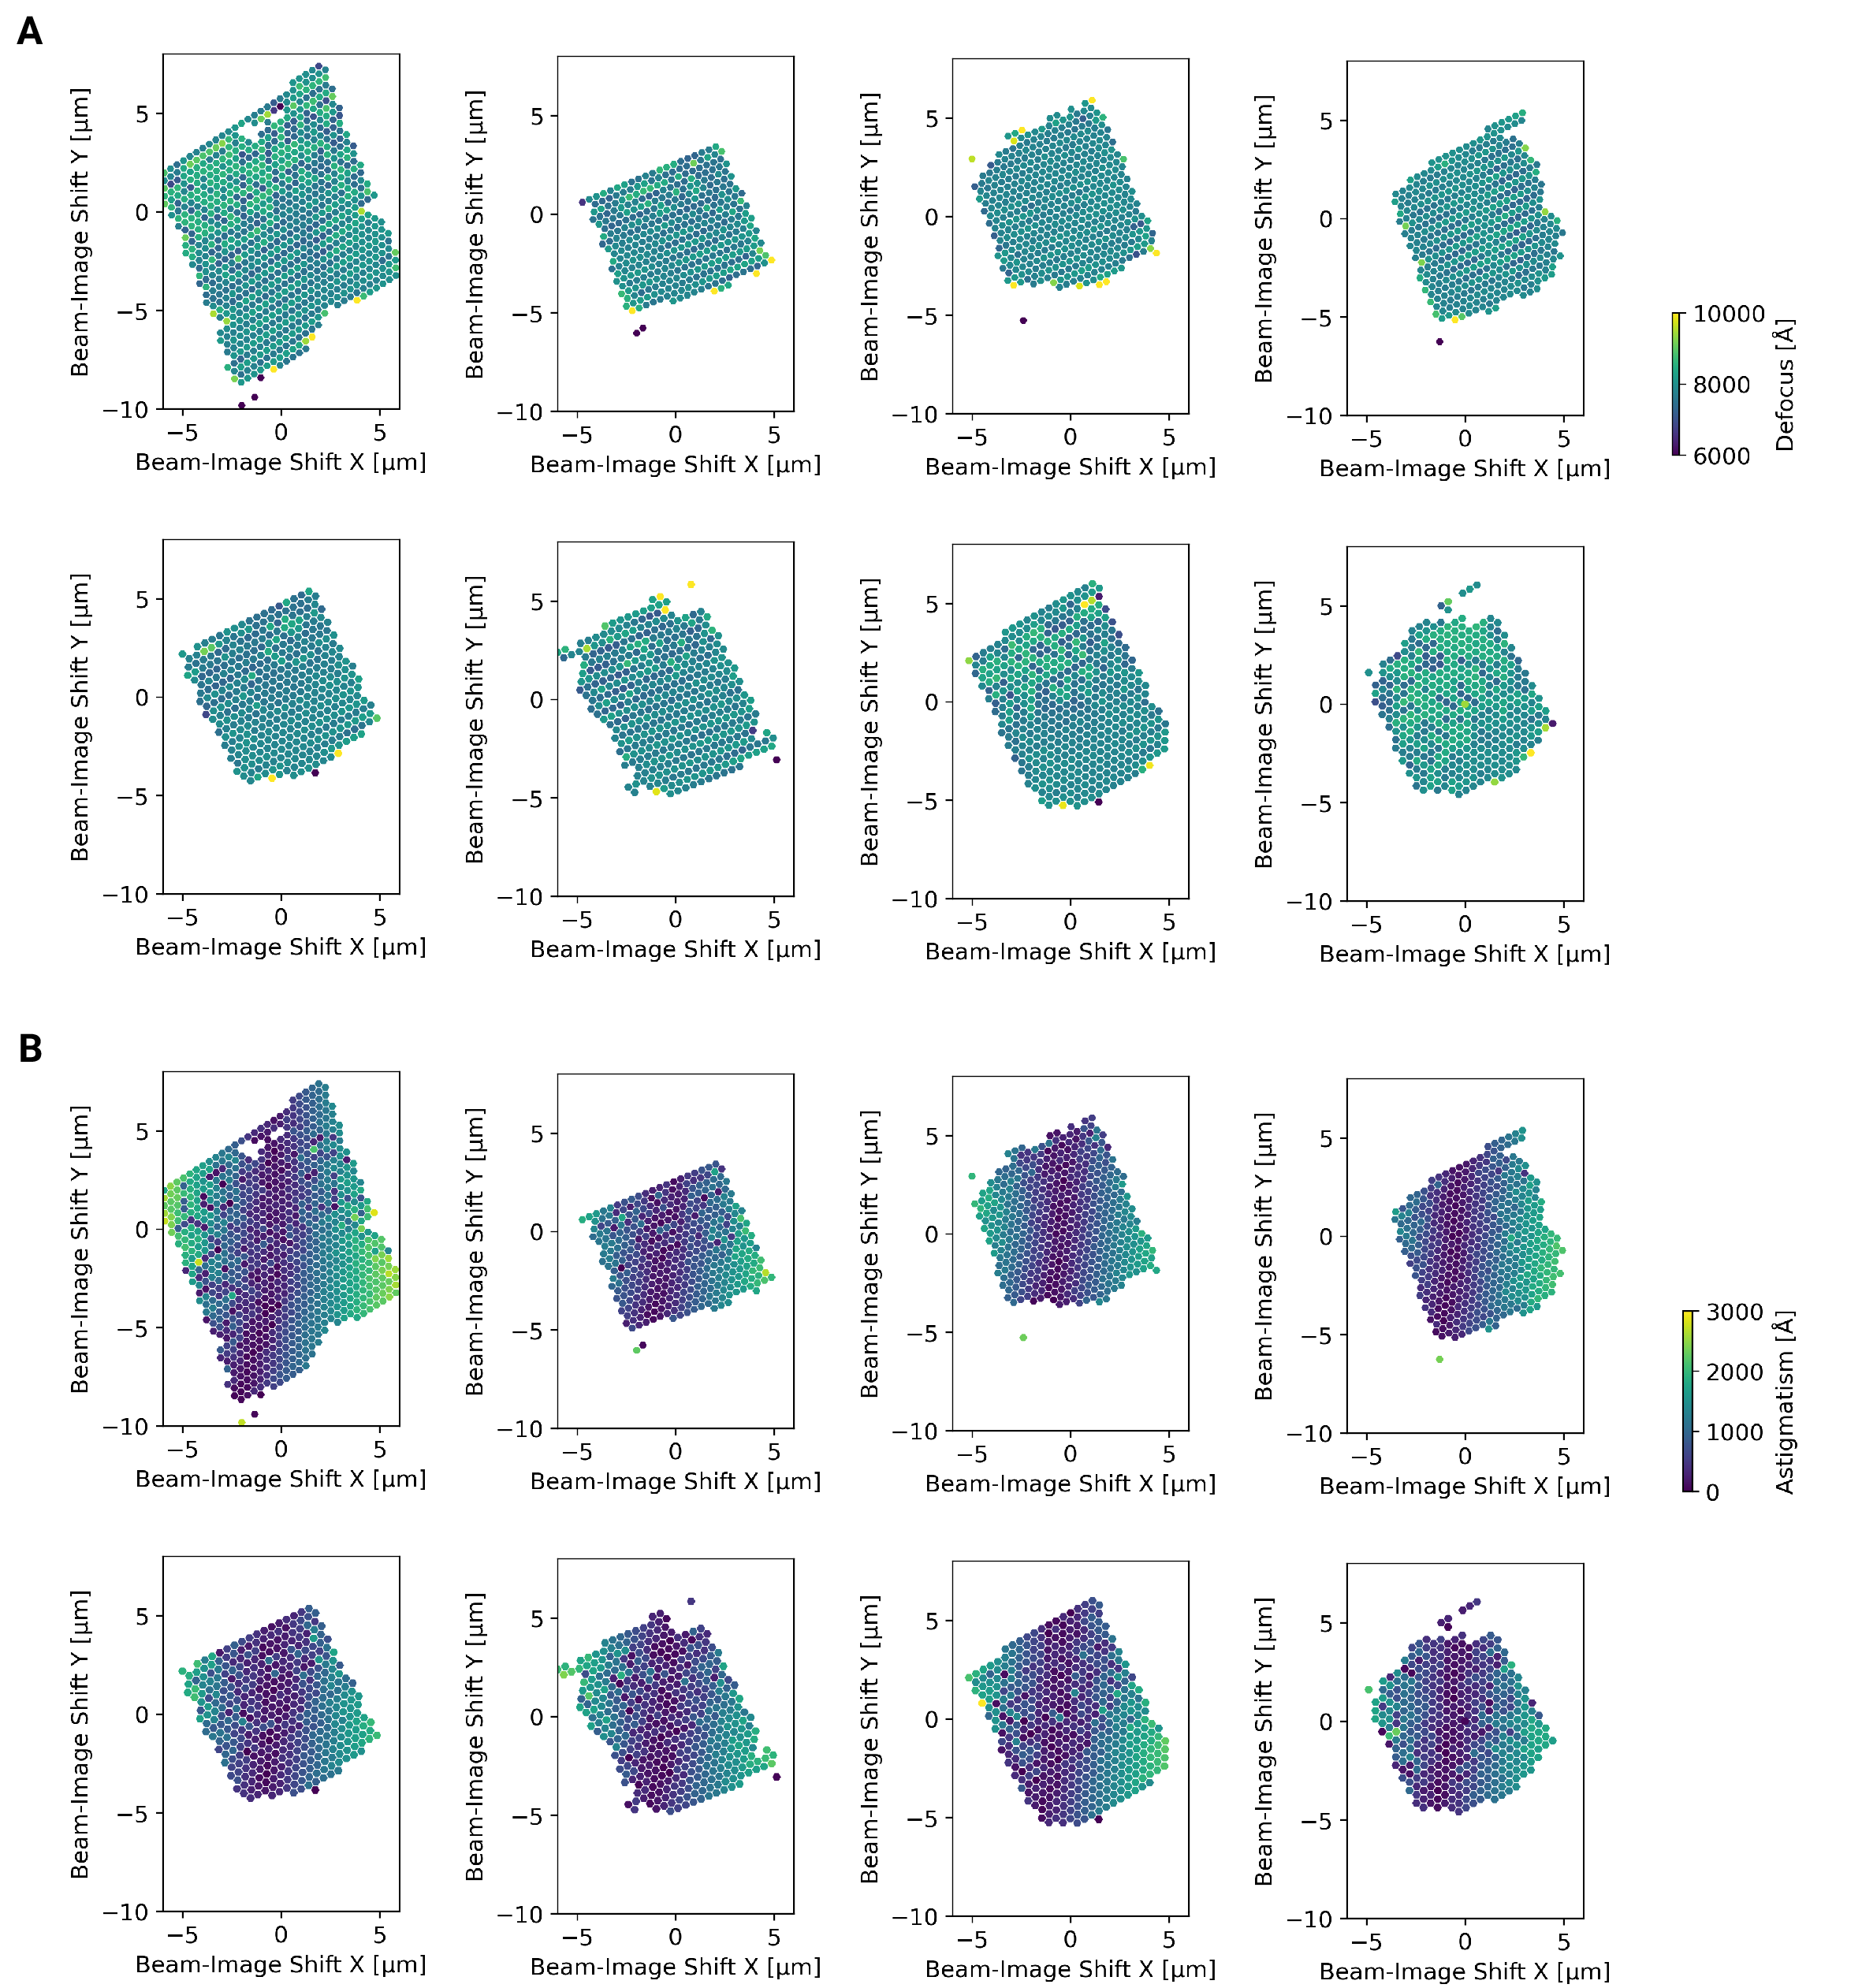

Figure S3: Defocus estimation of individual tiles of DeCo-Lace montages. (A) Defocus values of individual micrographs taken using the DeCo-Lace approach plotted as a function of the beam image-shift values. (B) Defocus astigmatism of individual micrographs taken using the DeCo-Lace approach plotted as a function of the image-shift values.

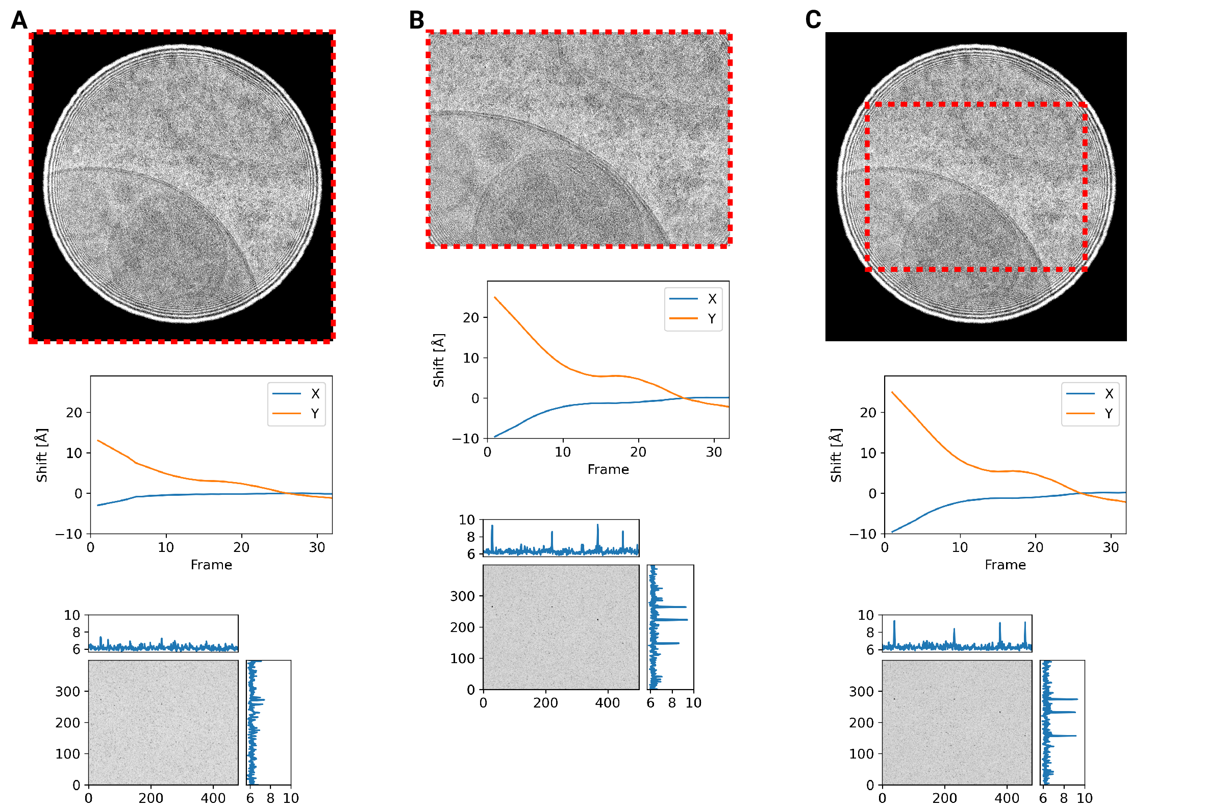

Figure S4: Motion correction of movies with condensed beams. At the top of each panel is an average of the movie that was motion-corrected with a red dashed box indicating the region that was used to estimate shifts. Below is a graph indicating the estimated shifts of the individual frames of the movie. Below this is the MIP of 2DTM using the large subunit of the mouse ribosome. (A) Motion correction of the whole movie. (B) Notion correction of a cropped region of the movie that eliminates the beam edges. (C) Motion correction of the whole movie, using only the central region to estimate the shifts

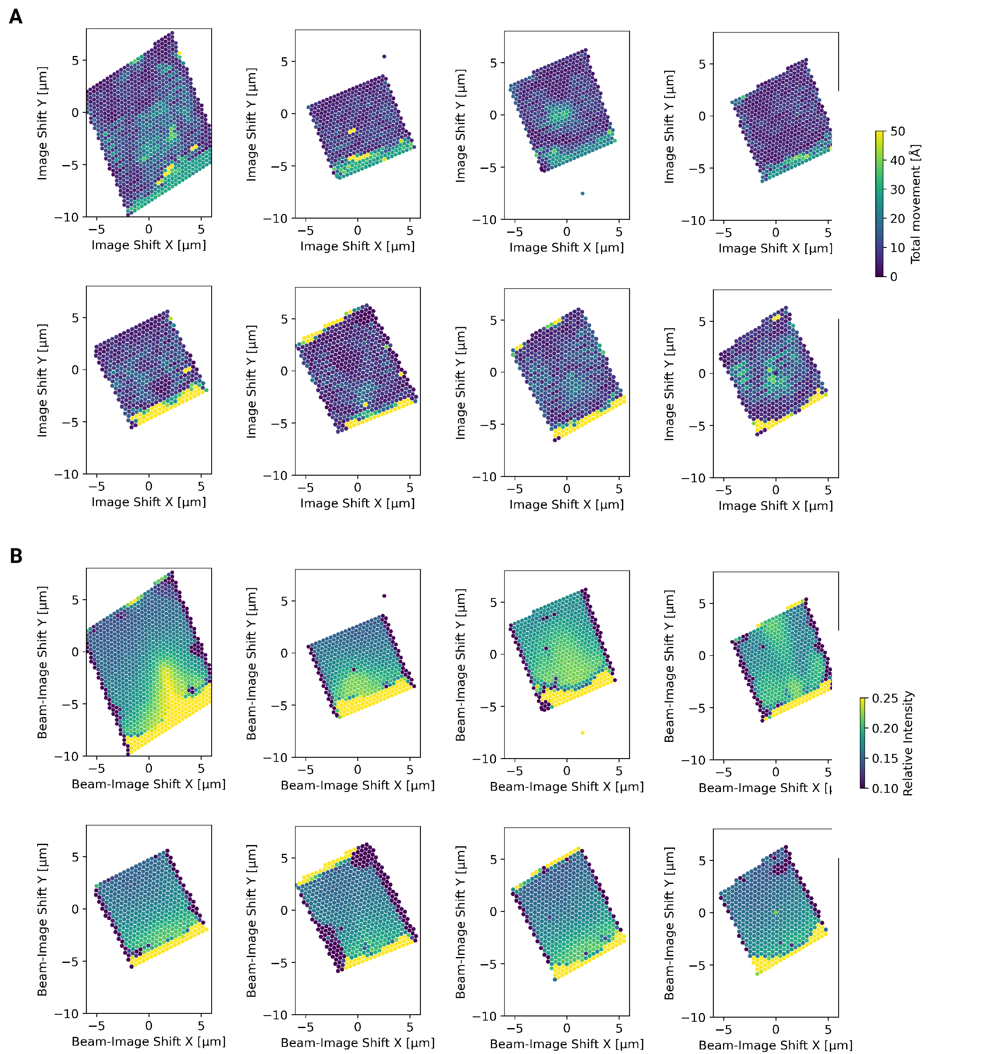

Figure S5: Motion correction of individual tiles imaged using the DeCo-LACE approach. (A) Total estimated motion of individual micrographs taken using the DeCo-Lace approach plotted as a function of the beam image-shift values. (B) Electron intensity of individual micrographs taken using the DeCo-Lace approach plotted as a function of the image-shift values.

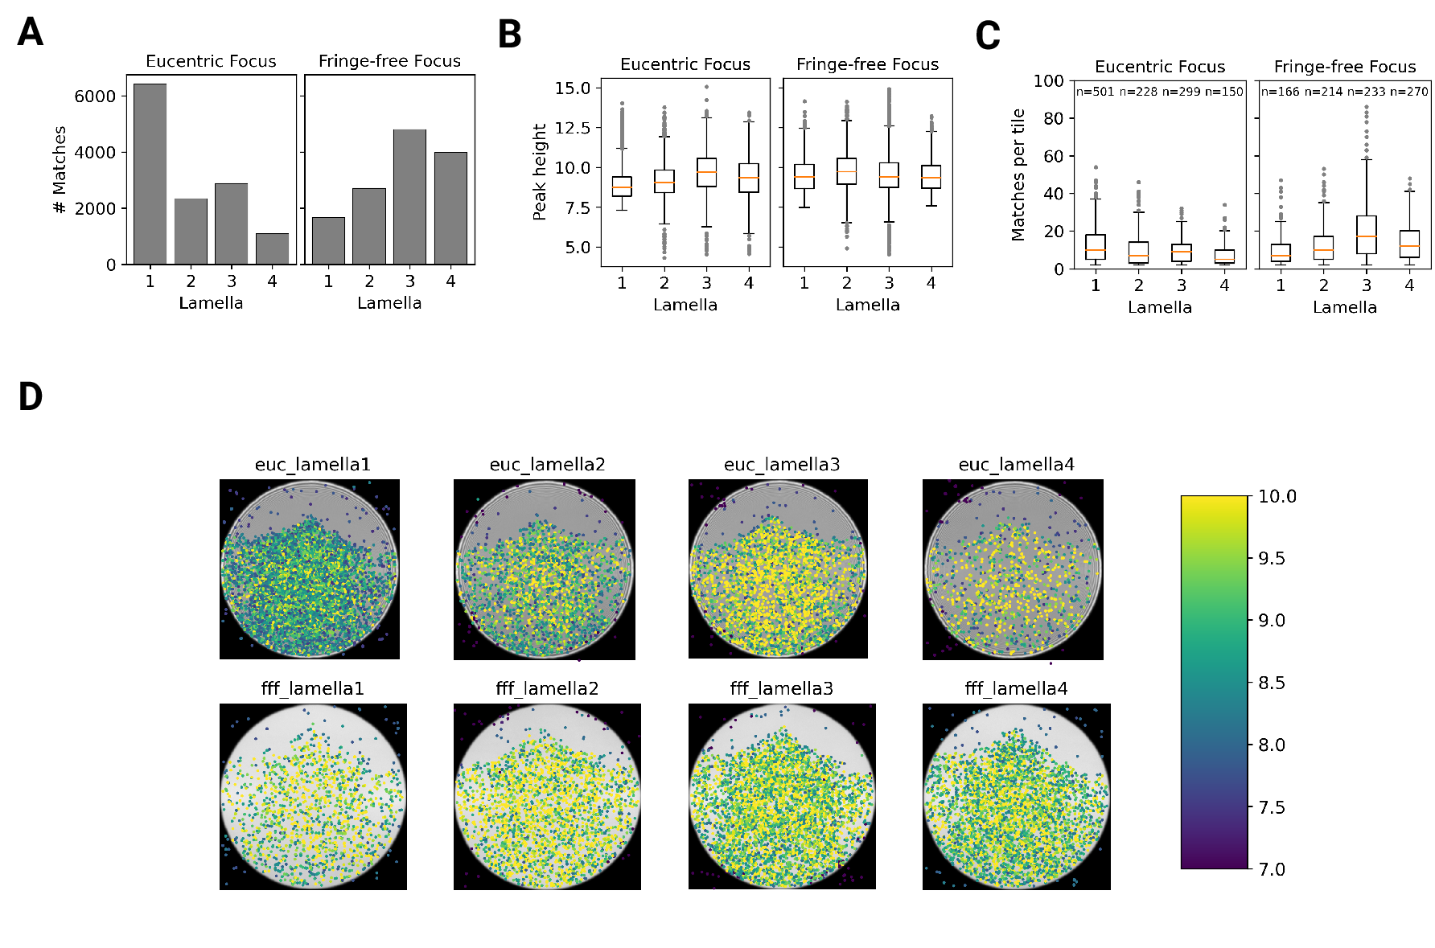

Figure 3: Statistics of 2DTM on lamella imaged using DeCo-LACE. (A) Number of detected targets in each lamella. (B) Distribution of targets per tile in each lamella. Only tiles with two or more targets were included. (C) Distribution of SNRs in each lamella. (D) For each lamella an average of all tiles is shown. Overlaid is a scatterplot of all detected targets in these tiles according to their in-tile coordinates. Scatterplot is color according to the detection SNR. There are no detected targets in the top circle-circle intersection due to radiation damage from previous exposures.

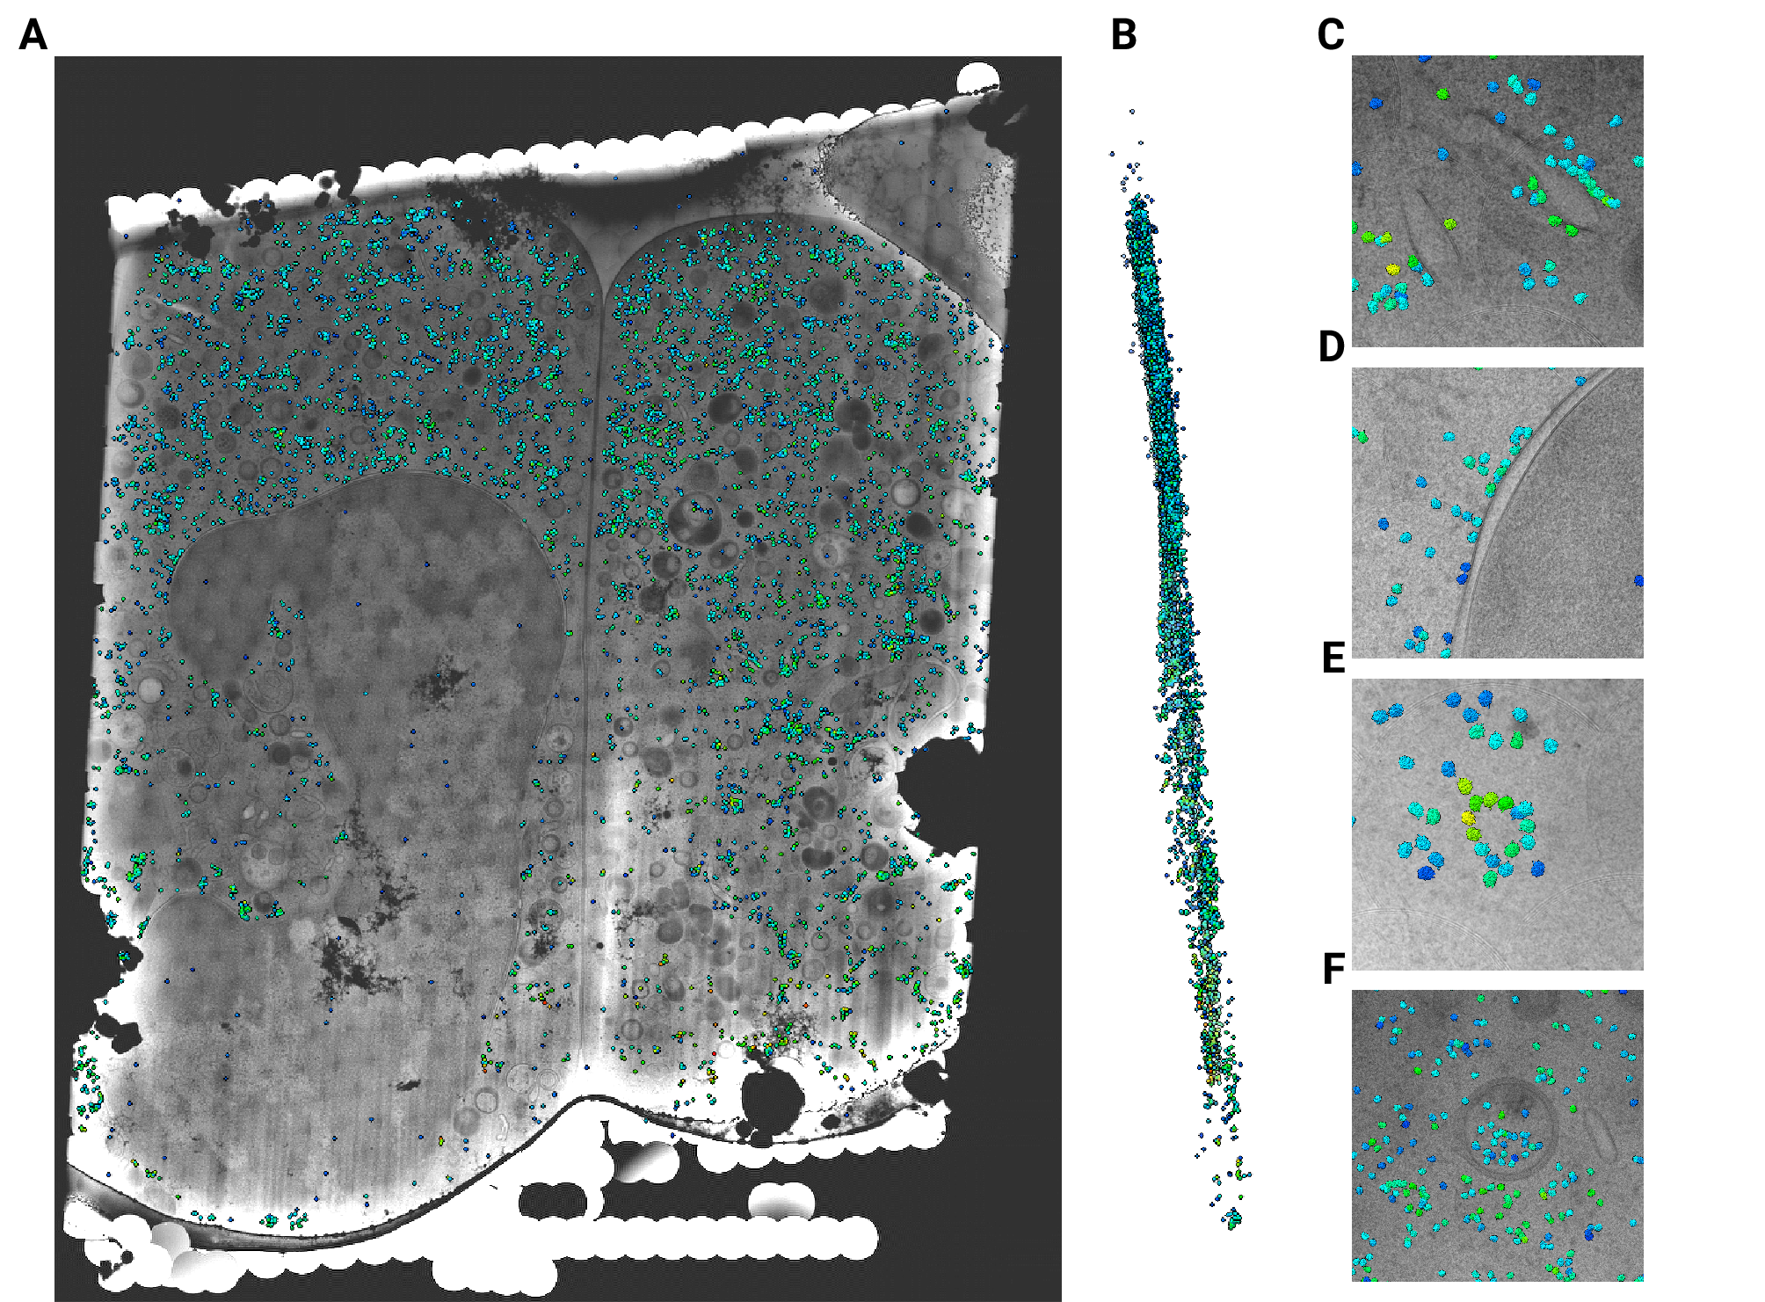

Figure 4: Template matching in lamella imaged using the DeCo-Lace approach at eucentric focus. (A) Montage of Lamella ${}_{\text{EUC}}$ 1 overlaid with detected targets according to their montage coordinates. (B) Side view of targets in the lamella, such that the direction of the electron beam is horizontal. (C-F) Magnified area of panel A showing rough ER with associated ribosomes (C), outer nuclear membrane with associated ribosomes (D), ribsomes arranged in a circular fashion(E), ribosomes enclosed in a less electron dense inclusion in a granule (F).

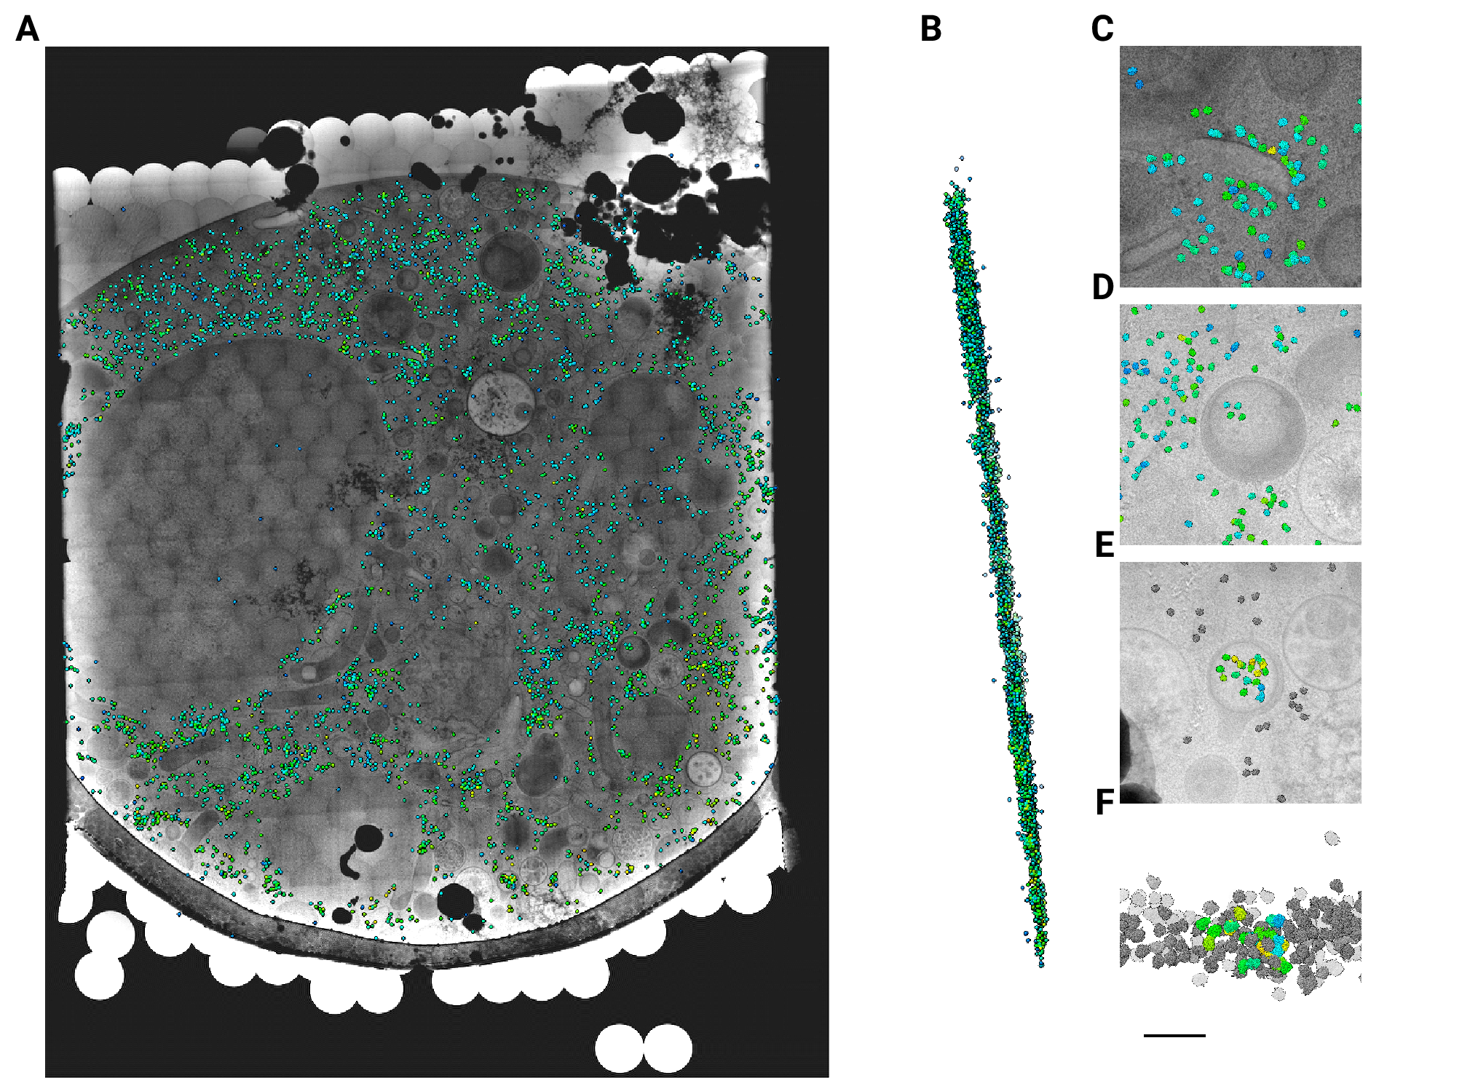

Figure 5: Template matching in lamella imaged using the DeCo-Lace approach at fringe-free focus. (A) Montage of Lamella ${}_{\text{FFF}}$ 4 overlaid with detected targets according to their montage coordinates. (B) Side view of targets in the lamella, such that the direction of the electron beam is horizontal. (C-E) Magnified area of panel A showing rough ER with associated ribosomes (C) and ribosomes enclosed in a less electron dense inclusion in a granule (D,E). (F) Side view of panel E with ribosomes situated inside the granule colored accoding to SNR and other ribosomes colored in grey.

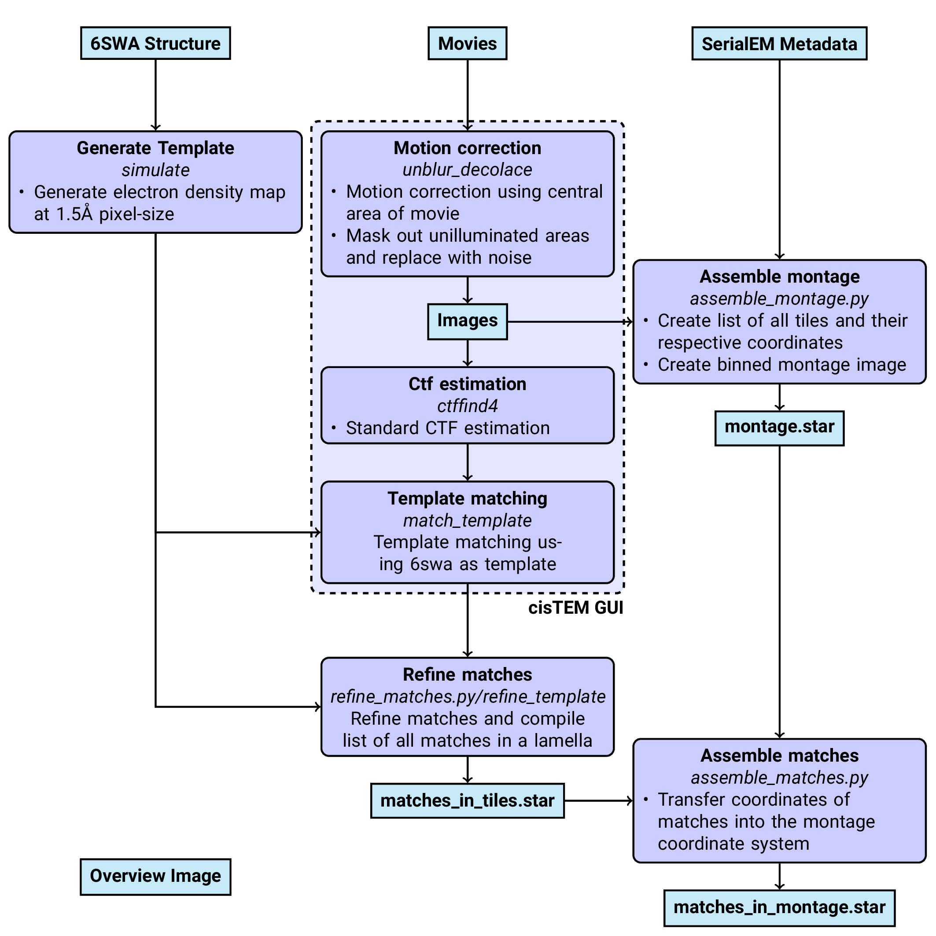

Figure 6: Workflow of DeCo-Lace processing

## References

1. **Label-free, normalized quantification of complex mass spectrometry data for proteomic analysis** Noelle M Griffin, Jingyi Yu, Fred Long, Phil Oh, Sabrina Shore, Yan Li, Jim A Koziol, Jan E Schnitzer *Nature Biotechnology* (2010-01) <https://doi.org/fshgnc> DOI: [10.1038/nbt.1592](https://doi.org/10.1038/nbt.1592) · PMID: [20010810](https://www.ncbi.nlm.nih.gov/pubmed/20010810) · PMCID: [PMC2805705](https://www.ncbi.nlm.nih.gov/pmc/articles/PMC2805705)

2. **Fluorescence microscopy** Jeff W Lichtman, José-Angel Conchello *Nature Methods* (2005-11-18) <https://doi.org/bbpg4n> DOI: [10.1038/nmeth817](https://doi.org/10.1038/nmeth817) · PMID: [16299476](https://www.ncbi.nlm.nih.gov/pubmed/16299476)

3. **A visual approach to proteomics** Stephan Nickell, Christine Kofler, Andrew P Leis, Wolfgang Baumeister *Nature Reviews Molecular Cell Biology* (2006-02-15) <https://doi.org/d6d5mq> DOI: [10.1038/nrm1861](https://doi.org/10.1038/nrm1861) · PMID: [16482091](https://www.ncbi.nlm.nih.gov/pubmed/16482091)

4. **Electron microscopy of frozen hydrated sections of vitreous ice and vitrified biological samples** AW McDowall, J-J Chang, R Freeman, J Lepault, CA Walter, J Dubochet *Journal of Microscopy* (1983-07) <https://doi.org/bdnzmv> DOI: [10.1111/j.1365-2818.1983.tb04225.x](https://doi.org/10.1111/j.1365-2818.1983.tb04225.x) · PMID: [6350598](https://www.ncbi.nlm.nih.gov/pubmed/6350598)

5. **Opening windows into the cell: focused-ion-beam milling for cryo-electron tomography** Elizabeth Villa, Miroslava Schaffer, Jürgen M Plitzko, Wolfgang Baumeister *Current Opinion in Structural Biology* (2013-10) <https://doi.org/f537jp> DOI: [10.1016/j.sbi.2013.08.006](https://doi.org/10.1016/j.sbi.2013.08.006) · PMID: [24090931](https://www.ncbi.nlm.nih.gov/pubmed/24090931)

6. **Electron tomography of cells** Lu Gan, Grant J Jensen *Quarterly Reviews of Biophysics* (2011-11-15) <https://doi.org/czj9hr> DOI: [10.1017/s0033583511000102](https://doi.org/10.1017/s0033583511000102) · PMID: [22082691](https://www.ncbi.nlm.nih.gov/pubmed/22082691)

7. **Single-protein detection in crowded molecular environments in cryo-EM images** JPeter Rickgauer, Nikolaus Grigorieff, Winfried Denk *eLife* (2017-05-03) <https://doi.org/gnq4q4> DOI: [10.7554/elife.25648](https://doi.org/10.7554/elife.25648) · PMID: [28467302](https://www.ncbi.nlm.nih.gov/pubmed/28467302) · PMCID: [PMC5453696](https://www.ncbi.nlm.nih.gov/pmc/articles/PMC5453696)

8. **Label-free single-instance protein detection in vitrified cells** JPeter Rickgauer, Heejun Choi, Jennifer Lippincott-Schwartz, Winfried Denk *Cold Spring Harbor Laboratory* (2020-04-24) <https://doi.org/gpbjfd> DOI: [10.1101/2020.04.22.053868](https://doi.org/10.1101/2020.04.22.053868)

9. **Locating macromolecular assemblies in cells by 2D template matching with cisTEM** Bronwyn A Lucas, Benjamin A Himes, Liang Xue, Timothy Grant, Julia Mahamid, Nikolaus Grigorieff *eLife* (2021-06-11) <https://doi.org/gkkc49> DOI: [10.7554/elife.68946](https://doi.org/10.7554/elife.68946) · PMID: [34114559](https://www.ncbi.nlm.nih.gov/pubmed/34114559) · PMCID: [PMC8219381](https://www.ncbi.nlm.nih.gov/pmc/articles/PMC8219381)

10. **Hallmarks of ribosomopathies** Kim R Kampen, Sergey O Sulima, Stijn Vereecke, Kim De Keersmaecker *Nucleic Acids Research* (2019-07-27) <https://doi.org/gpbjfm> DOI: [10.1093/nar/gkz637](https://doi.org/10.1093/nar/gkz637) · PMID: [31350888](https://www.ncbi.nlm.nih.gov/pubmed/31350888) · PMCID: [PMC7026650](https://www.ncbi.nlm.nih.gov/pmc/articles/PMC7026650)

11. **Diagnostic and prognostic implications of ribosomal protein transcript expression patterns in human cancers** James M Dolezal, Arie P Dash, Edward V Prochownik *BMC Cancer* (2018-03-12) <https://doi.org/gc87j9> DOI: [10.1186/s12885-018-4178-z](https://doi.org/10.1186/s12885-018-4178-z) · PMID: [29530001](https://www.ncbi.nlm.nih.gov/pubmed/29530001) · PMCID: [PMC5848553](https://www.ncbi.nlm.nih.gov/pmc/articles/PMC5848553)

12. **Inhibition of Dihydroorotate Dehydrogenase Overcomes Differentiation Blockade in Acute Myeloid Leukemia** David B Sykes, Youmna S Kfoury, François E Mercier, Mathias J Wawer, Jason M Law, Mark K Haynes, Timothy A Lewis, Amir Schajnovitz, Esha Jain, Dongjun Lee, … David T Scadden *Cell* (2016-09) <https://doi.org/f3r5jr> DOI: [10.1016/j.cell.2016.08.057](https://doi.org/10.1016/j.cell.2016.08.057) · PMID: [27641501](https://www.ncbi.nlm.nih.gov/pubmed/27641501) · PMCID: [PMC7360335](https://www.ncbi.nlm.nih.gov/pmc/articles/PMC7360335)